Summit VPN Certificate management.

The Summit Anyconnect policy is configured to authenticate based on Certificate and Username/Password. Active Directory is the source for the username and password. Sunlight.summit.local is the server with the Certificate Authority role utilized for the certificates used for the VPN Authentication.

Clients will need an identity certificate signed by the CA installed to authenticate to the Anyconnect VPN policy. Certificates are automatically issued for workstations that are members of the domain by the current CA installed on Sunlight.summit.local.

For non-domain joined workstations, this process consists of creating a signing request on the workstation, signing that request with the CA and installing the signed certificate on the workstation.

1. Create a CSR for the workstation. Launch MMC on the client workstation and select File Add/Remove Snap-in

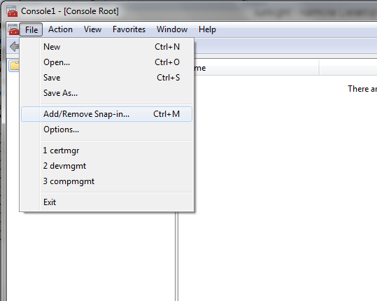

1. Select Certificates, click Add, Select My User Account and click Finish then OK

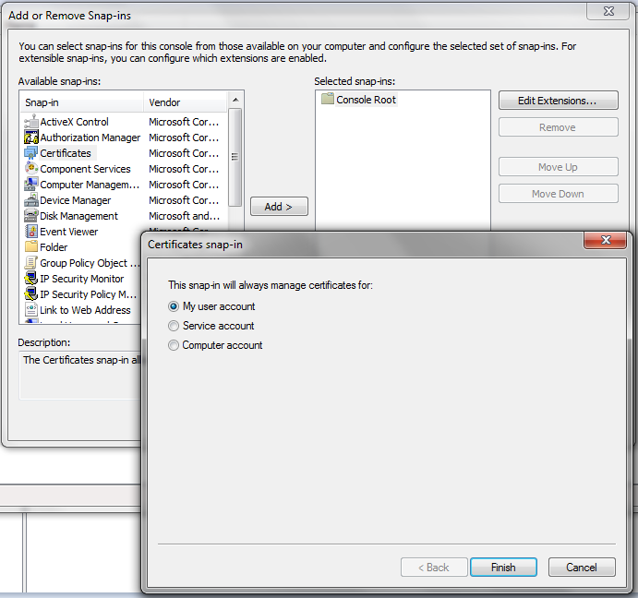

1. Select Personal, Right click the center pane, select All Tasks > Advanced Options > Create Custom Request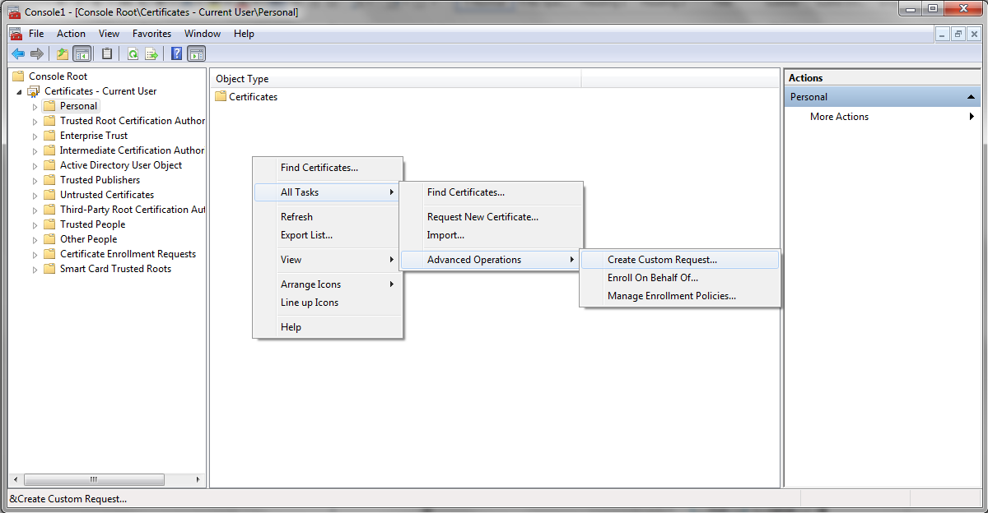
2. Click Next

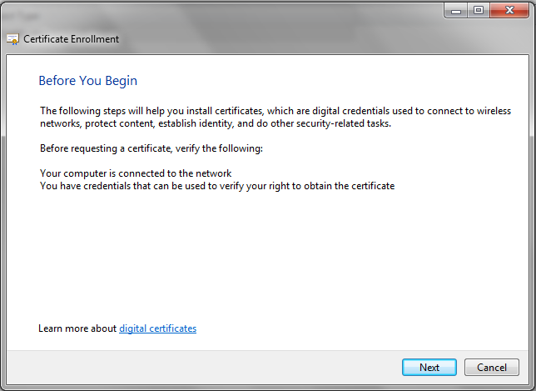

1. Select Proceed without enrollment policy and click Next.

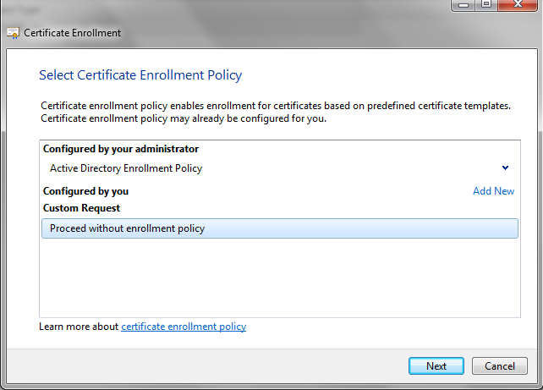

1. No template, PKCS #10 > Next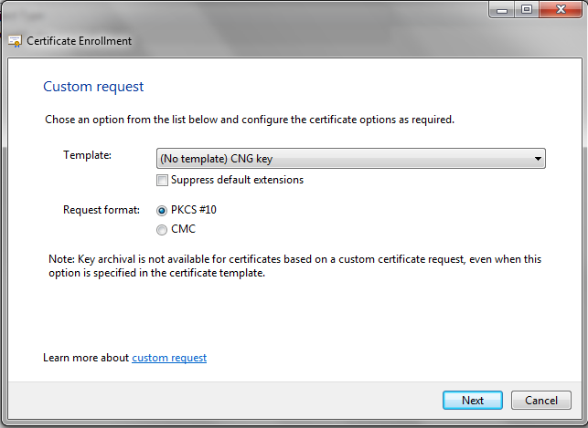
2. Expand Details and click Properties

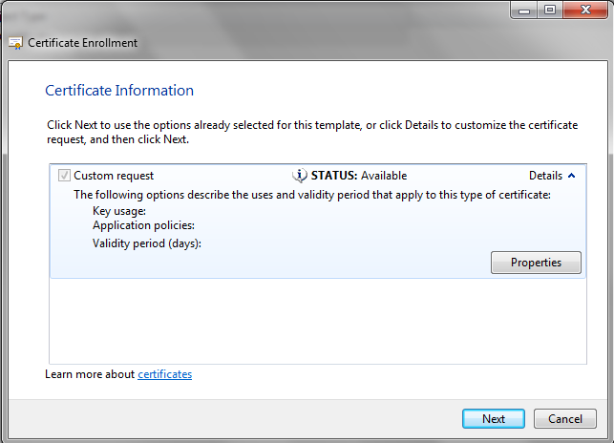

1. On the General Tab enter Friendly Name 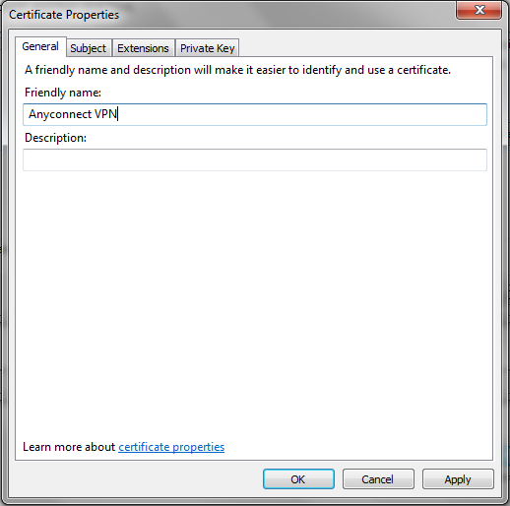
2. On the Subject Tab add a Common name and any additional identifying attributes for the client CSR.

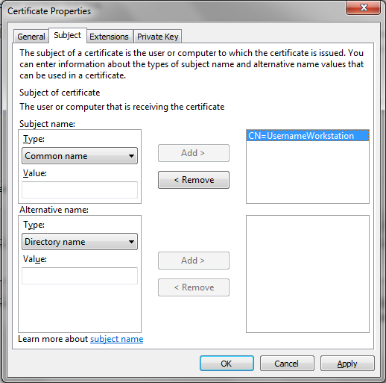

1. On the Extensions Tab, click the Key Usage option and add Digital Signature to the selected options.

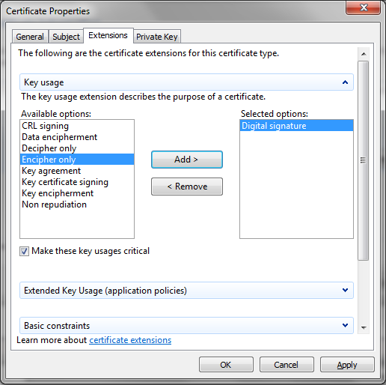

1. Click OK then Next. Select a location to save the CSR export and click Finish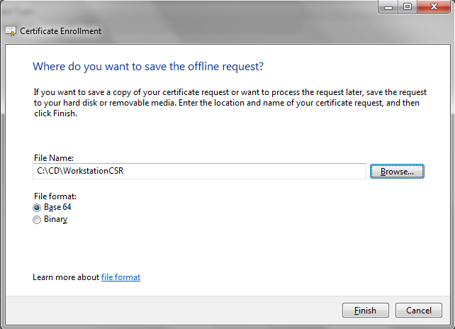
2. Copy the CSR file to sunlight c:\certs
3. Sign the CSR in powershell with the certreq command

Ex: certreq.exe -submit -attrib "CertificateTemplate:User" WorkstationCSR WorkstationCert  
When prompted, highlight summit-SUNLIGHT-CA (Kerberos) and click OK

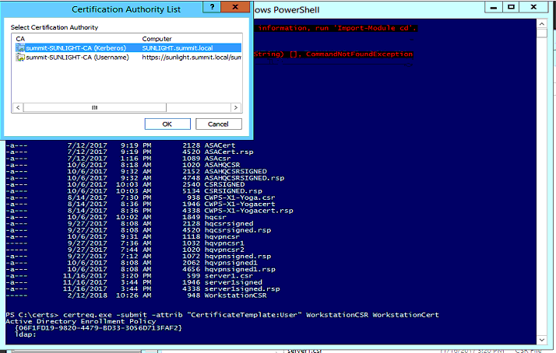

1. Copy WorkstationCert back to the user computer. On the workstation, Right-click > Install Certificate

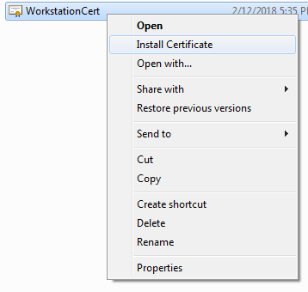

1. Click Next

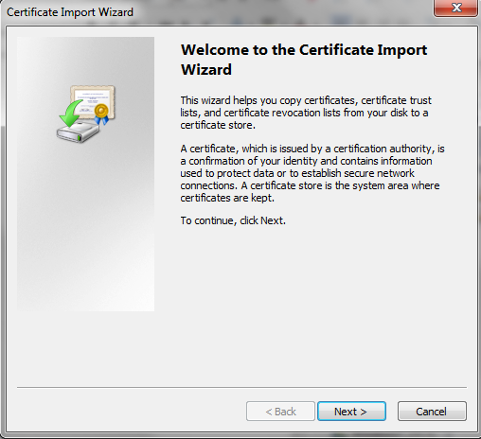

1. Click Next

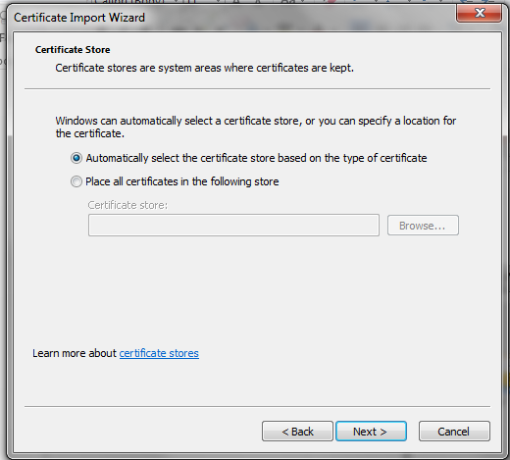

1. Click Finish and OK

